***LASHING CERTIFICATE***

This certificate is to attest that, as required by_( Nome Cliente), we inspected the lashing (tying) of the Boat inside the container of the type 40’ Flat Rack with prefix and number, ( Número Containers), booking (Número Reserva)concluding that they were done in a safe way using lashing straps according to the Regulatory Standards of the Labor Ministry - NR 11, ensuring that the cargo is in safe conditions for maritime transport.

**Details of the Cargo:**

|  |  |
| --- | --- |
| **Loading Port** | Suape – Brazil |
| **Destination Port** | Port of Everglades – USA |

|  |  |  |  |
| --- | --- | --- | --- |
| **Nº** | **Cargo Description** | **Dimensions**  **Length X Width X Height** | **GROSS**  **WEIGHT CARGO** |
| 1 | Boat NX 340 | 11,12m X 3,15m X 3,76m | 6.000 Kg |

**Details of the Lashing Materials**

|  |  |  |  |
| --- | --- | --- | --- |
| **Nº** | **Description** | **Quantity** | **Safe Working Load (SWL)** |
| 1 | Lashing Straps | 09 | 6 t (each lashing Straps) |

**REMARKS:**

1 - The Lashing materials were estimated to nearly (Quantidade de cintas /nine) times the total capacity of the cargo stowed in the container, giving a safety margin in lashing.

2 - The lashing straps were passed through the load to be lashed at the container's lashing points, preventing the lateral and longitudinal displacement of the load.

3 – The Lashing Material as well as the lashing of the cargo in the container were the responsibility of the company (Nome da empresa que forneceu o material).

4 - The cargo stowed in the container has lateral excess of (largura 27 cm do execesso lateral da carga) cm on both sides and excess height of (excesso de altura da carga 190 cm).

5 – It is important observing during shipping if the straps are strained, and if necessary, tighten them.

Recife, on December 12

th 2023.

**PHOTOGRAPHIC REPORT**

**Photo 01 –** Container Identification – TCLU 600782-3

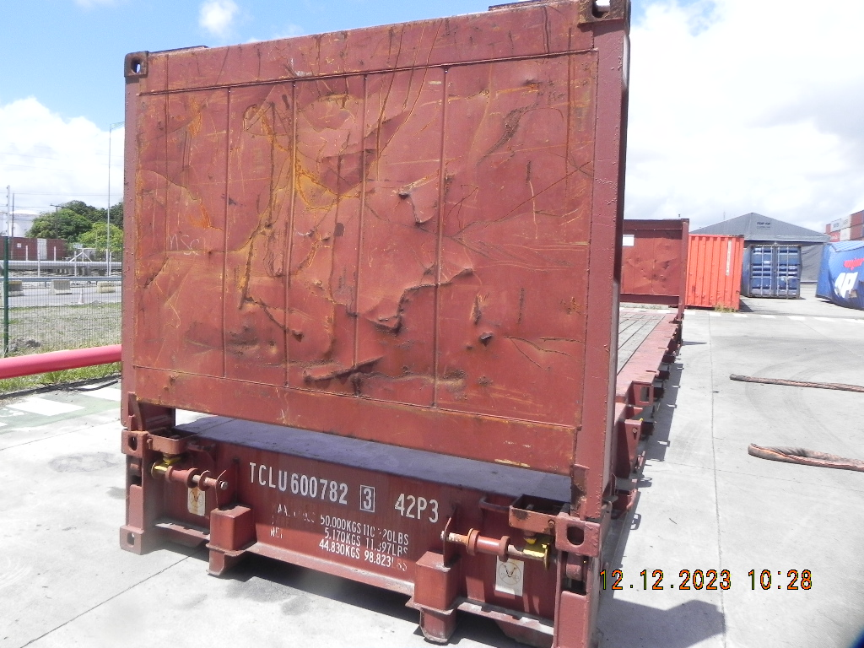

**Photo 02 –** Container Identification Plate.

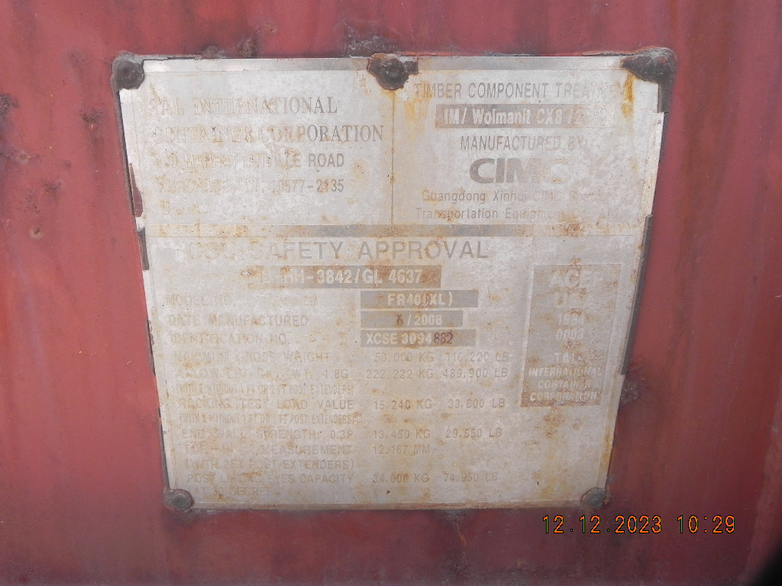

**PHOTOGRAPHIC REPORT**

**Photos 03 – 04:** View of the boat to be lashed on top of the transport vehicle. **<-obs**

.

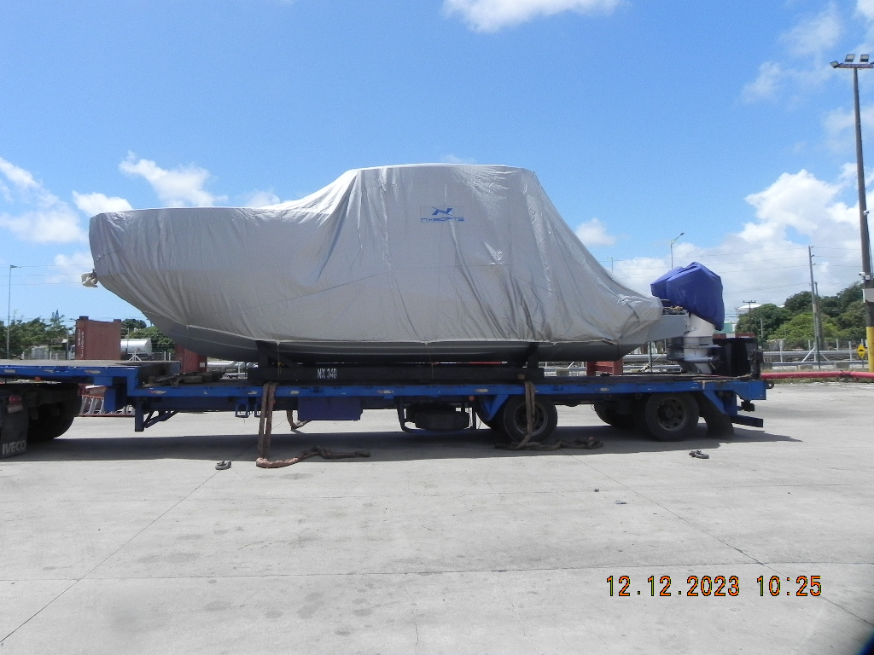

**Photo 03**

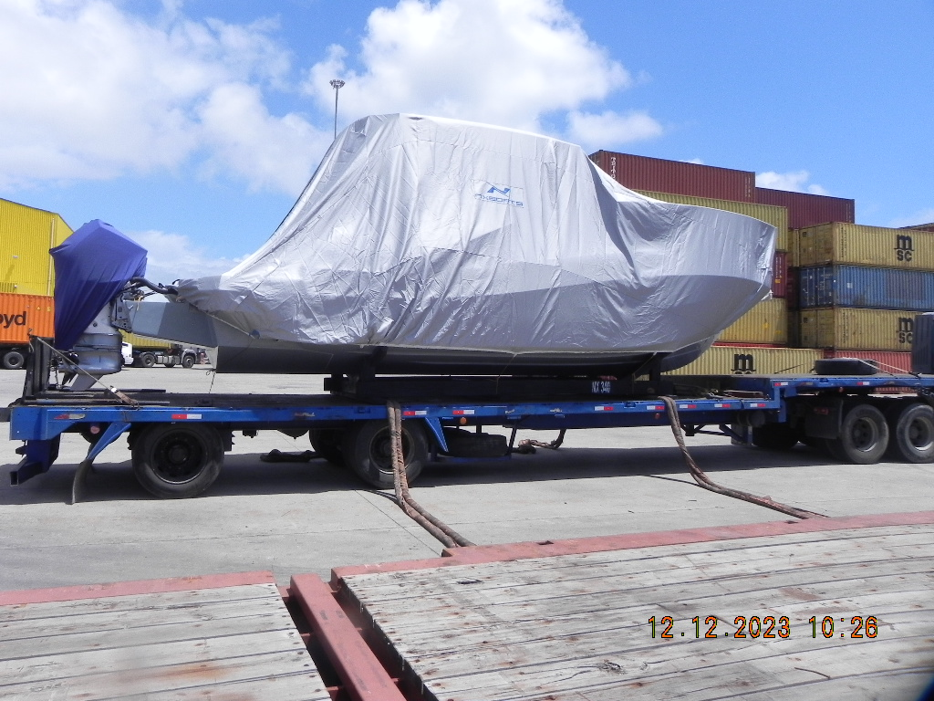

**Photo 04**

**PHOTOGRAPHIC REPORT**

**Photos 05 – 06:** Vision of the boat with the wooden base positioned in the container. **<-obs**

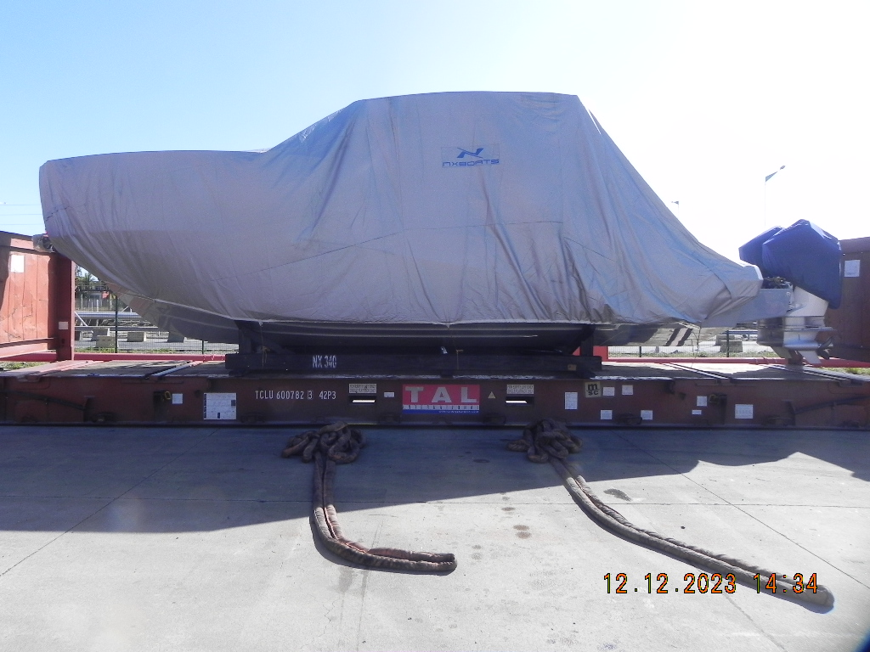  
**Photo 05**

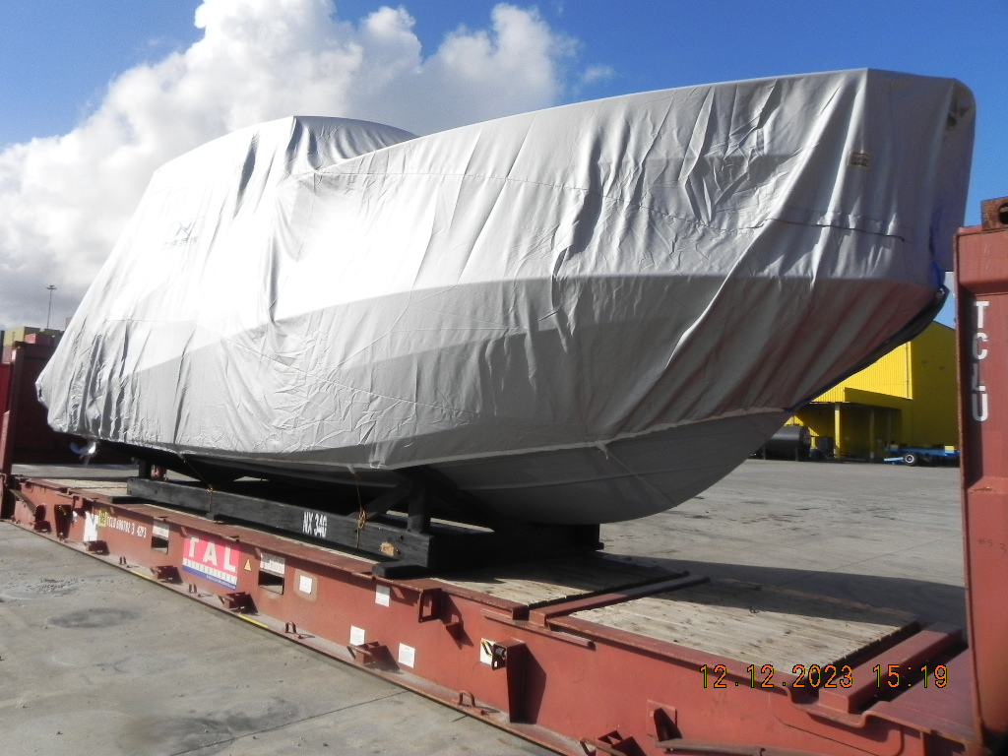

**Photo 06**

**PHOTOGRAPHIC REPORT**

**Photos 07 - 08:** Capacity of the lashing straps and buckles used in the wooden base of the boat lashed in the container.

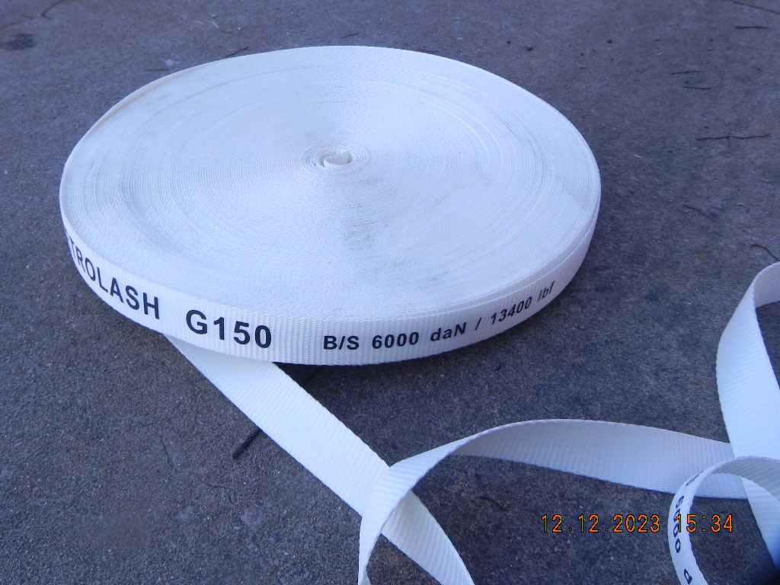

**Photo 07**

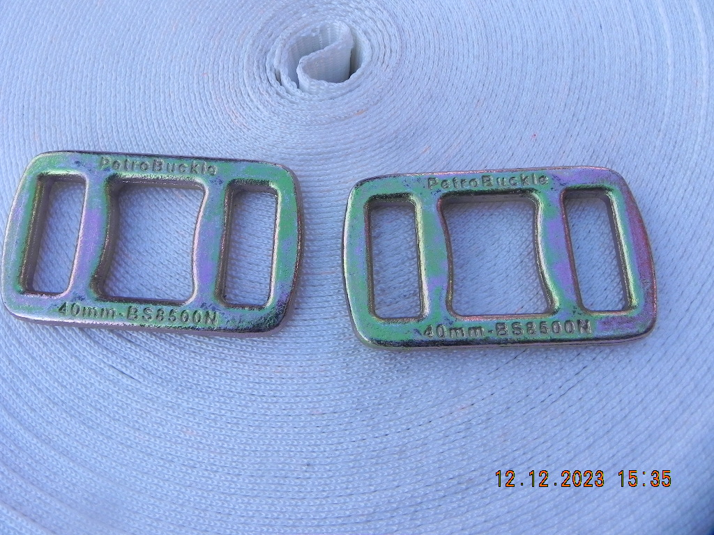

**Photo 08**

**PHOTOGRAPHIC REPORT**

**Photo 09 – 10:** View of the wooden base of the boat strapped with straps, preventing the lateral and longitudinal displacement of the load. Protections were placed between the lashing straps and the container’s structures in order to avoid cuts on the straps.

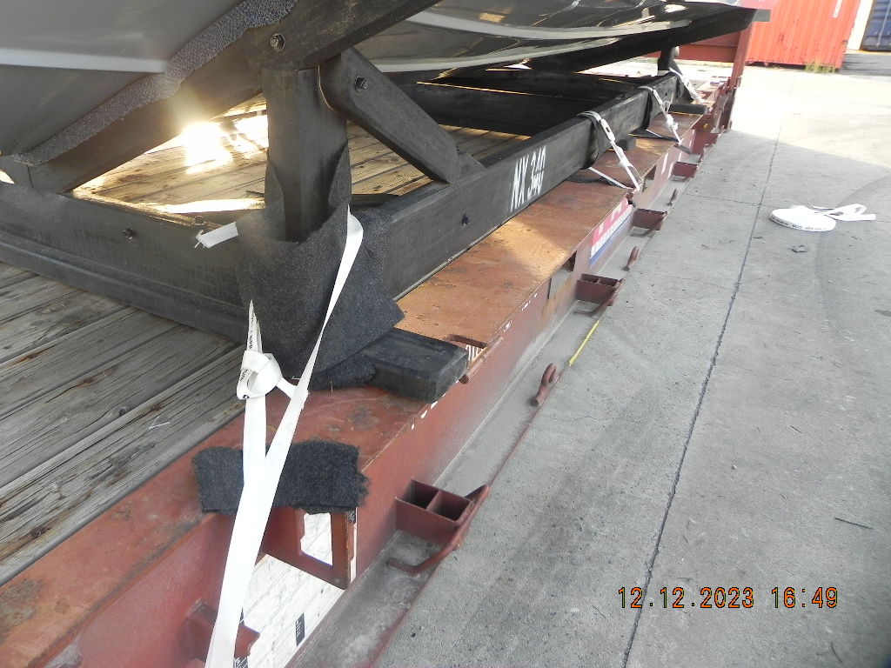

**Photo 09**

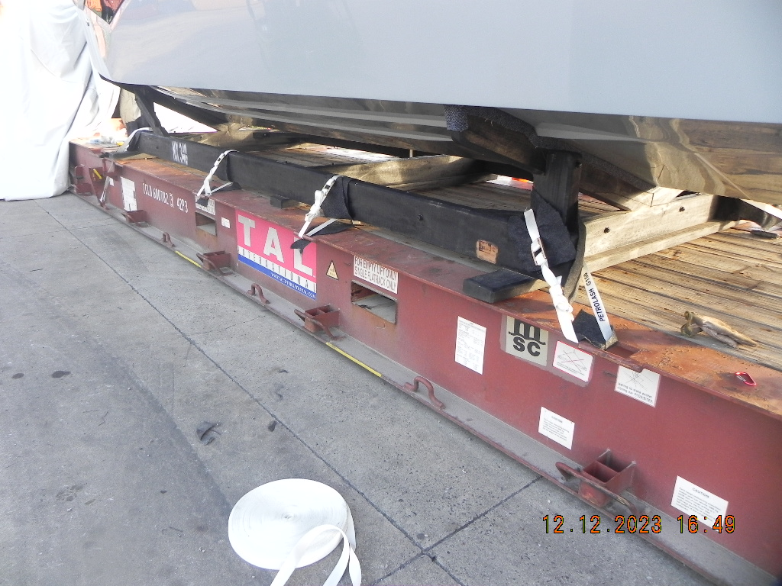

**Photo 10**

**PHOTOGRAPHIC REPORT**

**Photos 11 – 12:** Vision of the capabilities of the lashing straps and buckles used in the mooring of the boat in the container.



**Photo 11**

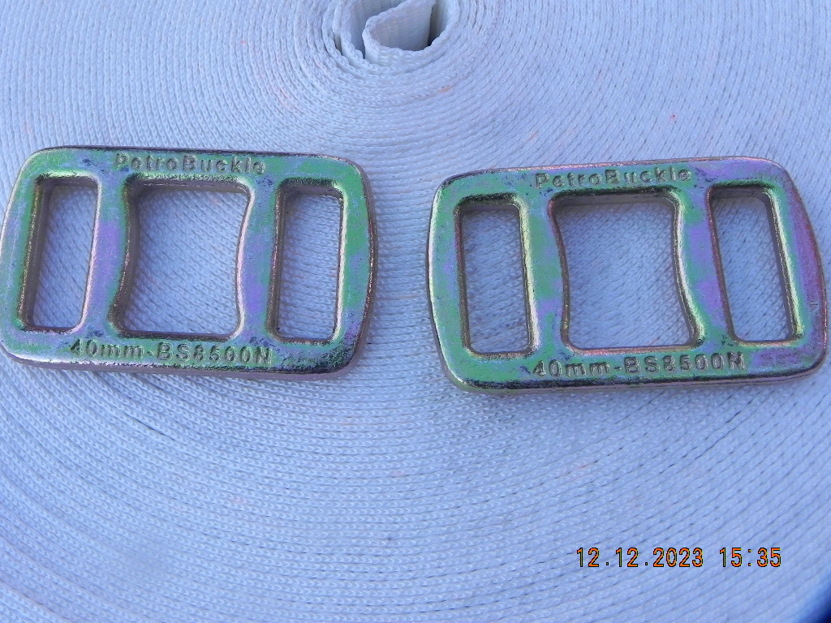

**Photo 12**

**PHOTOGRAPHIC REPORT**

**Photo 13 –** View of mid ship starboard side mooring of the boat with the lashing straps, preventing the lateral and longitudinal displacement of the load.

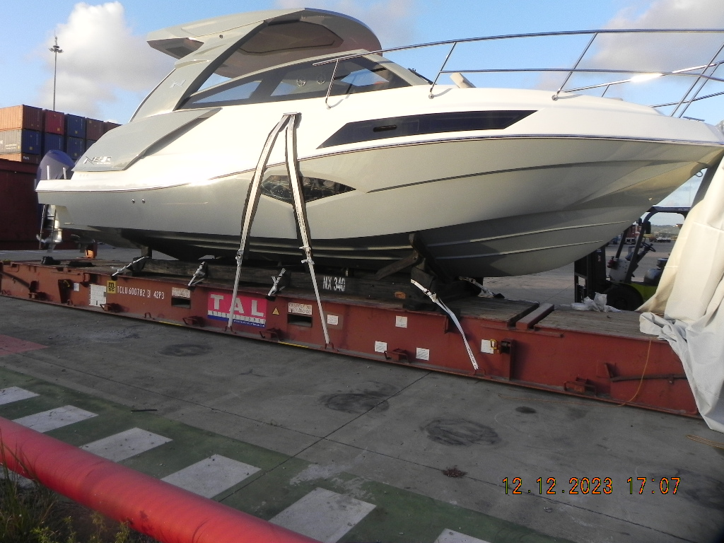

**Photo 14** – View of mid ship port side mooring of the boat with lashing straps, preventing the lateral and longitudinal displacement.

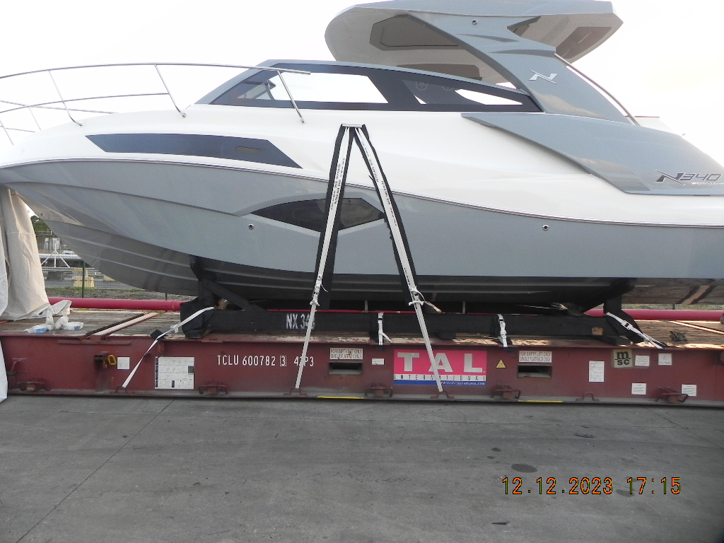

**PHOTOGRAPHIC REPORT**

**Photo 15 – 16:** View of the aft mooring.

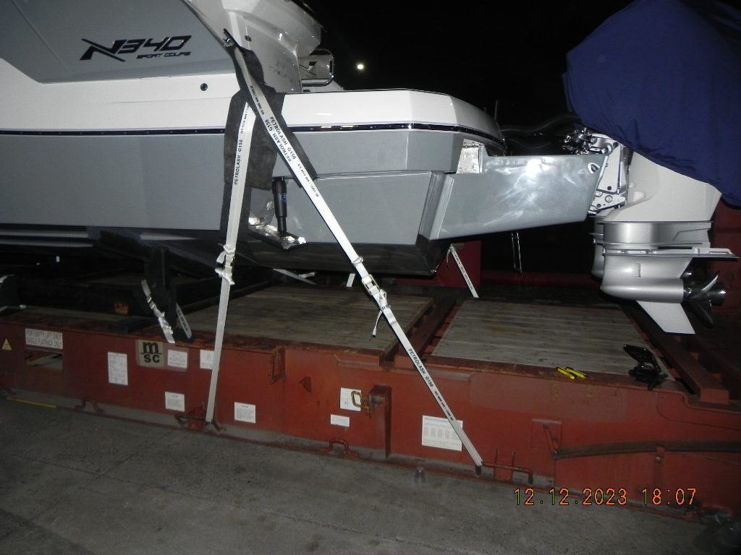

**Photo 15**

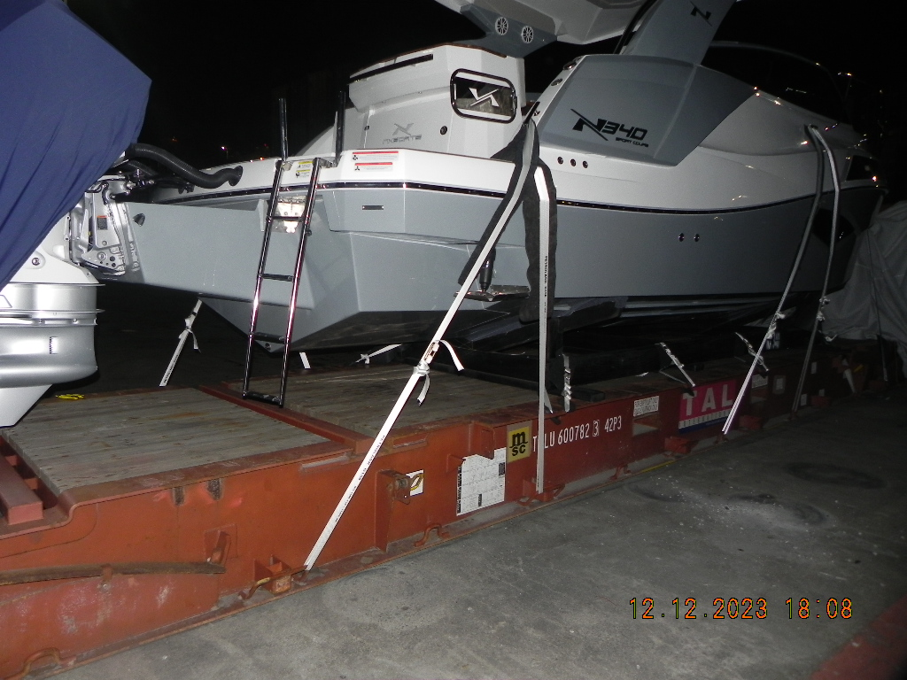

**Photo 16**

**PHOTOGRAPHIC REPORT**

**Photo 17 – 18:** General vision of the mooring of the boat.

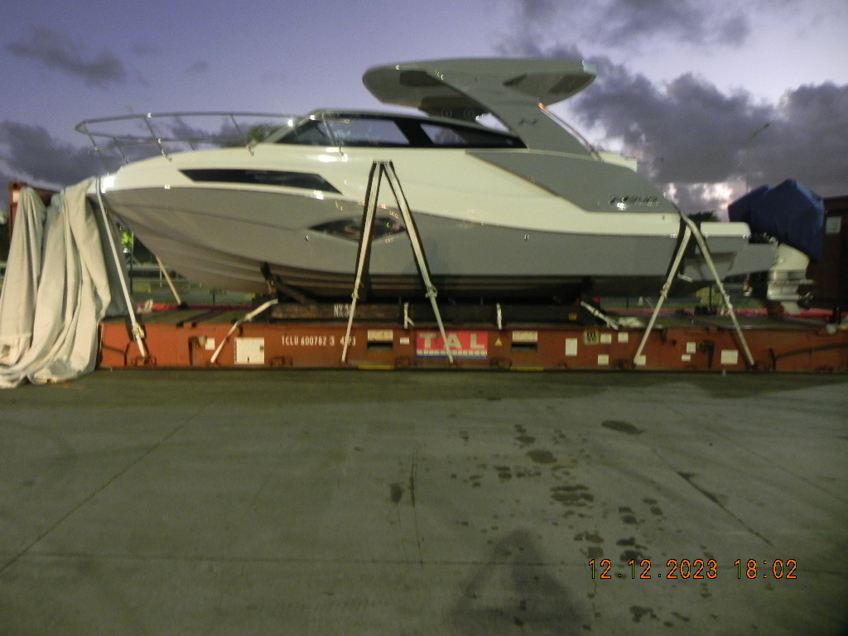

**Photo 17**

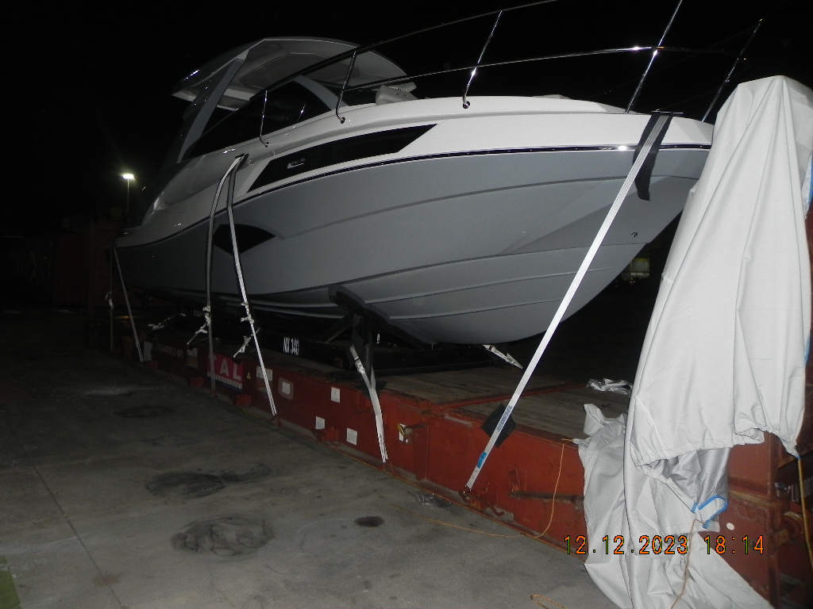

**Photo 18**

**PHOTOGRAPHIC REPORT**

**Photo 19 – 20:** Protections placed between the lashing straps and structures of the boat in order to avoid scratches.

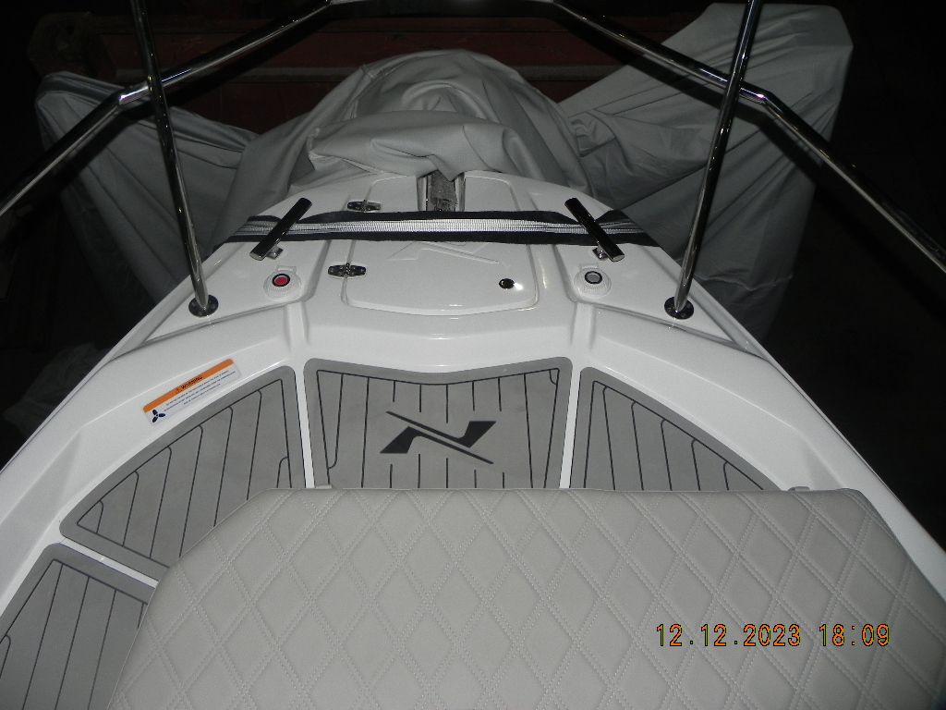

**Photo 19**

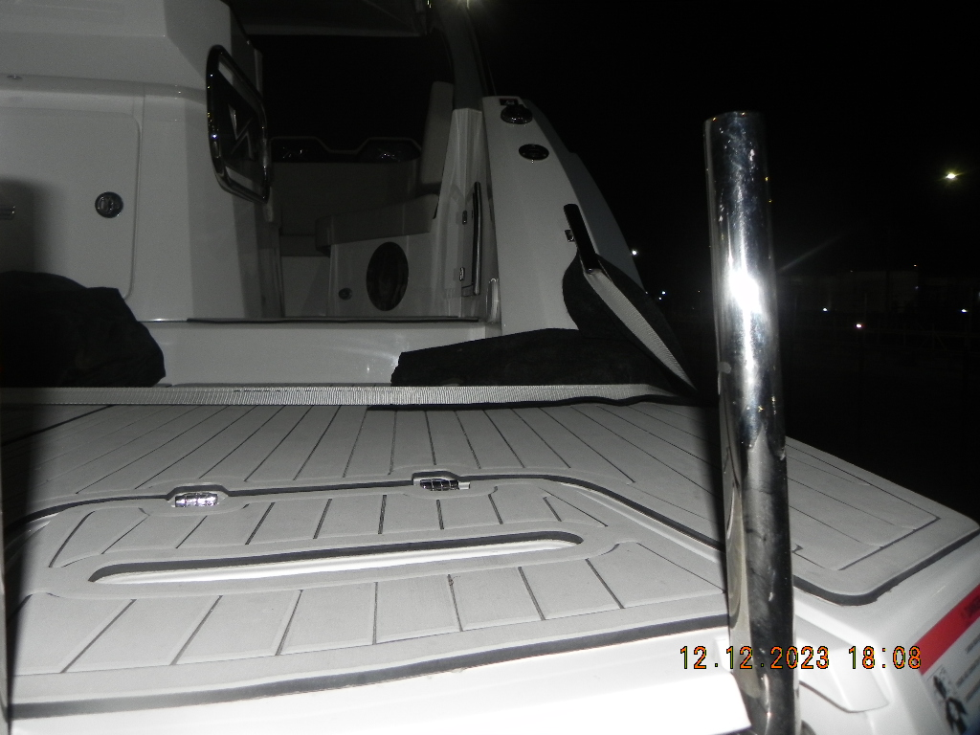

**Photo 20**

**PHOTOGRAPHIC REPORT**

**Photo 21:** Excess height 190cm

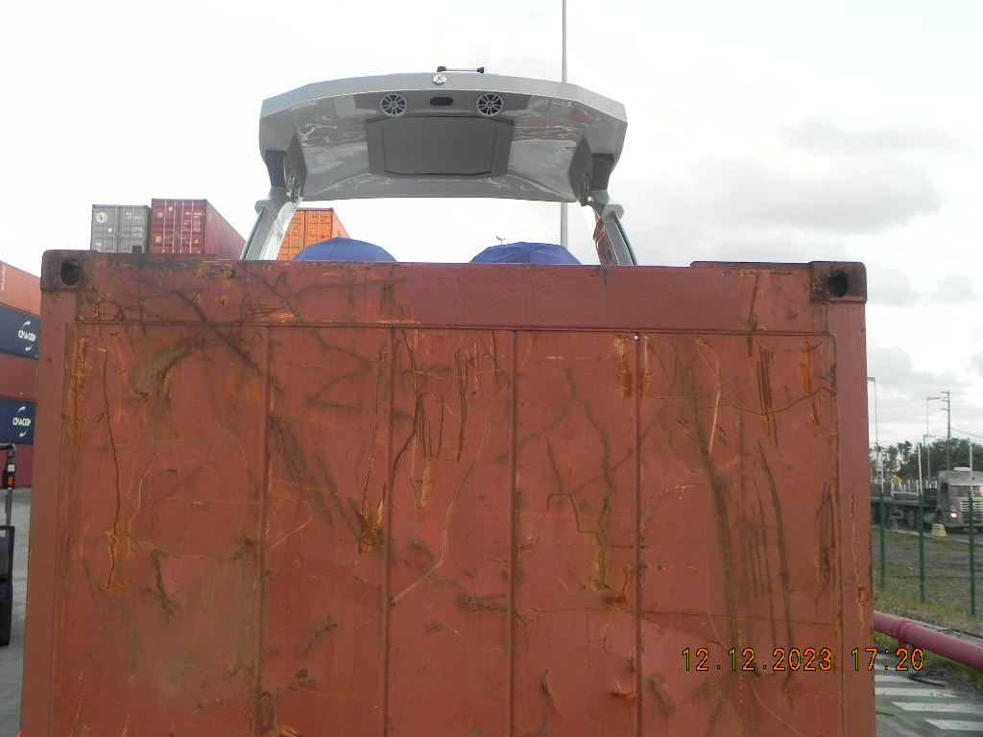

**Photo 22:** Lateral excess of 27 cm on both sides

